**Management Information Systems**

**(CSA 4045)-Slot A**

**B.uday kiran (192011028) Lab Programs:**

**a1.UML Diagrams.**

**b2.MY SQL Programs.**

**c3.VB Programs.**

**a2.AIRPORT MANAGEMENT SYSTEM**

**1.USE CASE DIAGRAM:**

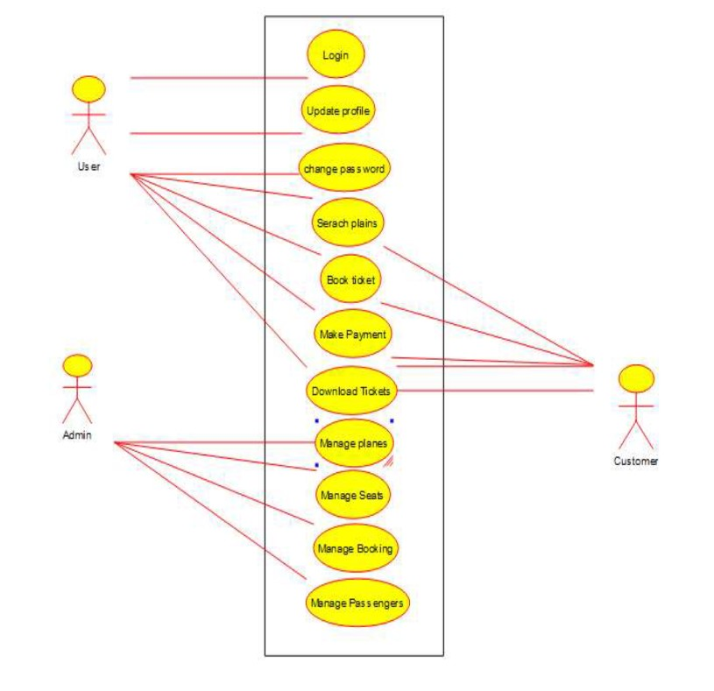

**2. SEQUENCE DIAGRAM:**

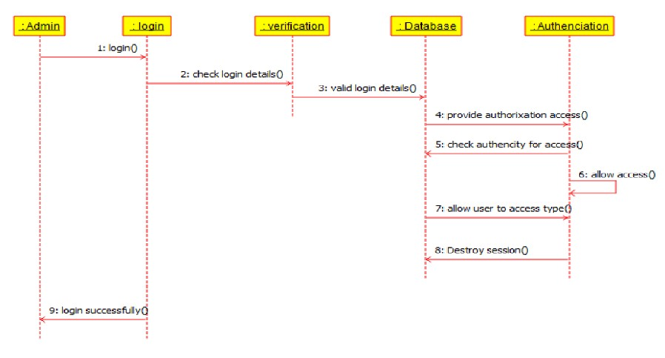

**3. CLASS DIAGRAM:**

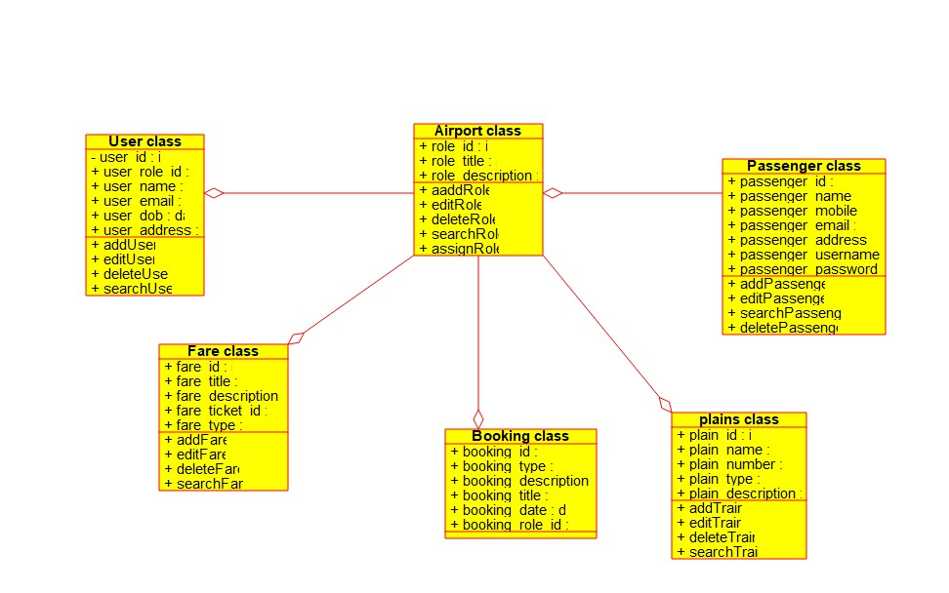

**4. ACTIVITY DIAGRAM:**

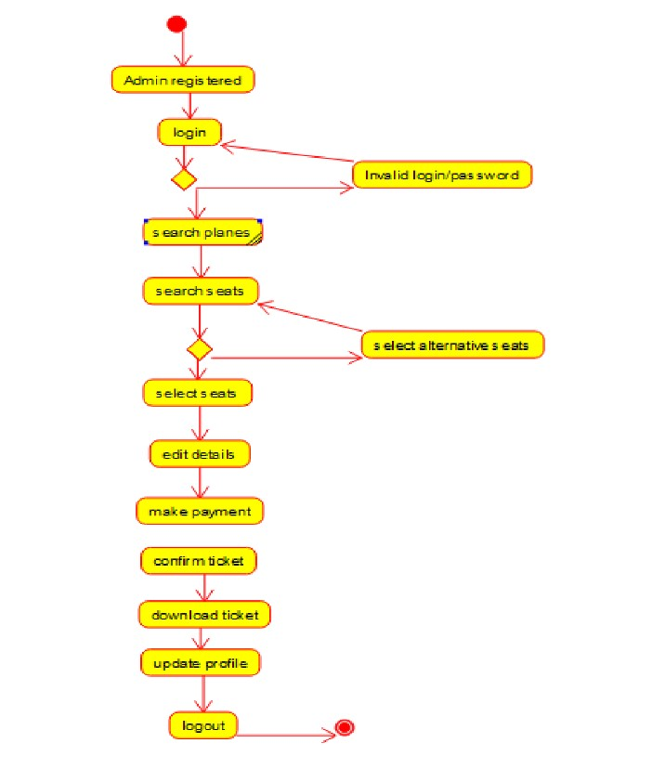

**a1.Library Management System**

**1.USE CASE DIAGRAM:**

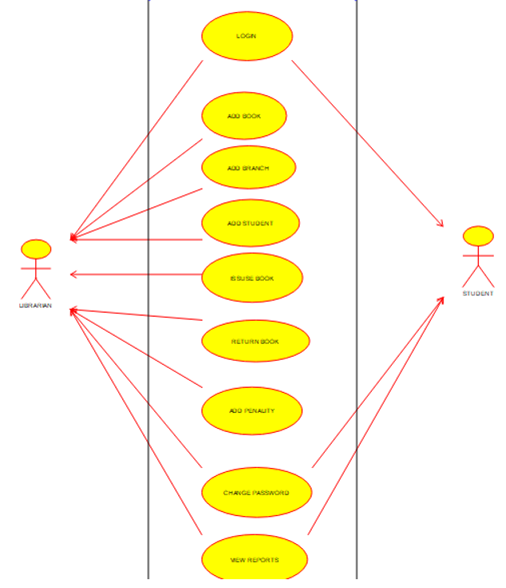

**2. SEQUENCE DIAGRAM**

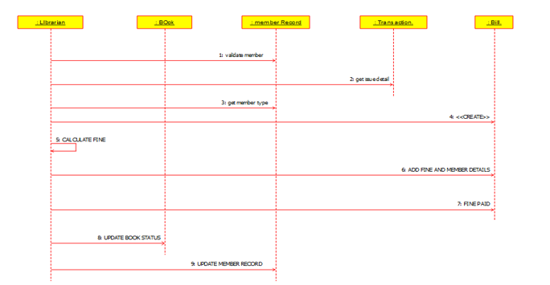

**3. CLASS DIAGRAM:**

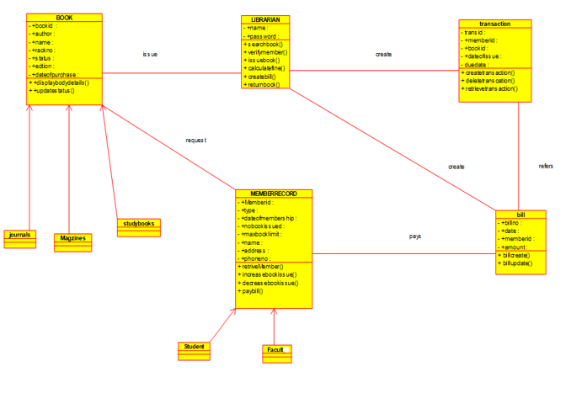

**4. ACTIVITY DIAGRAM:**

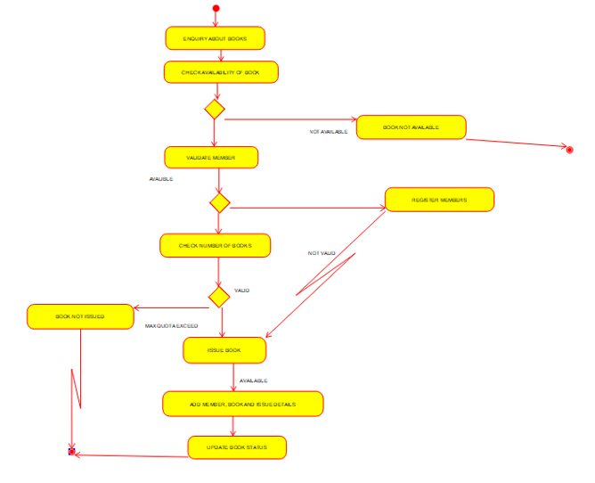

**a3.Railway Reservation system for booking a train ticket**

**1.USE CASE DIAGRAM:**

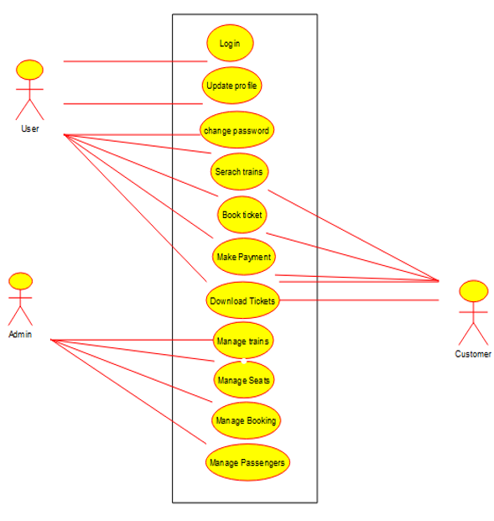

**2. SEQUENCE DIAGRAM:**

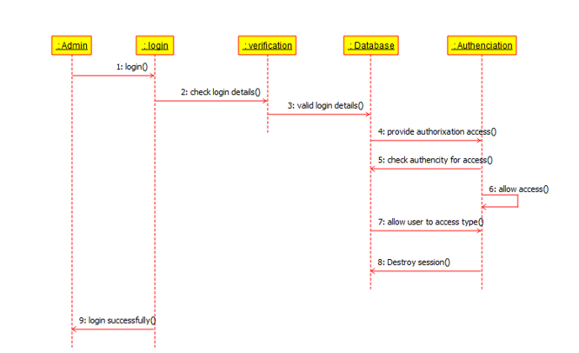

**3. CLASS DIAGRAM:**

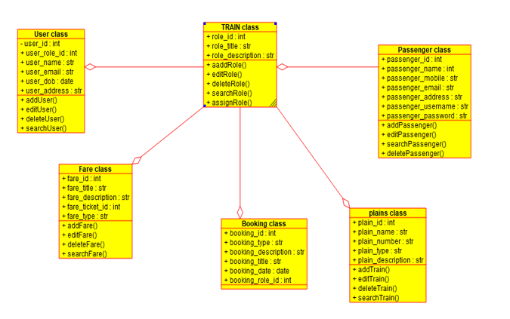

**4. ACTIVITY DIAGRAM:  
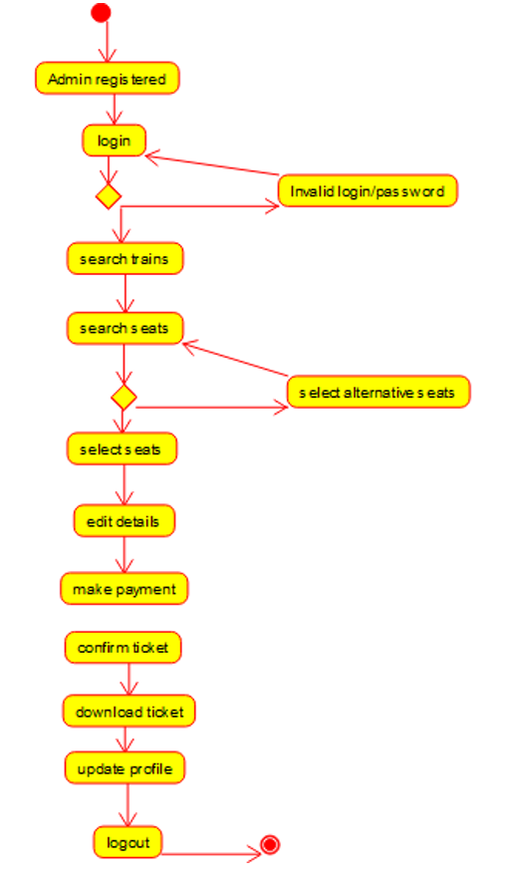**

**a4.** **Online Food ordering system**

**1.USE CASE DIAGRAM**

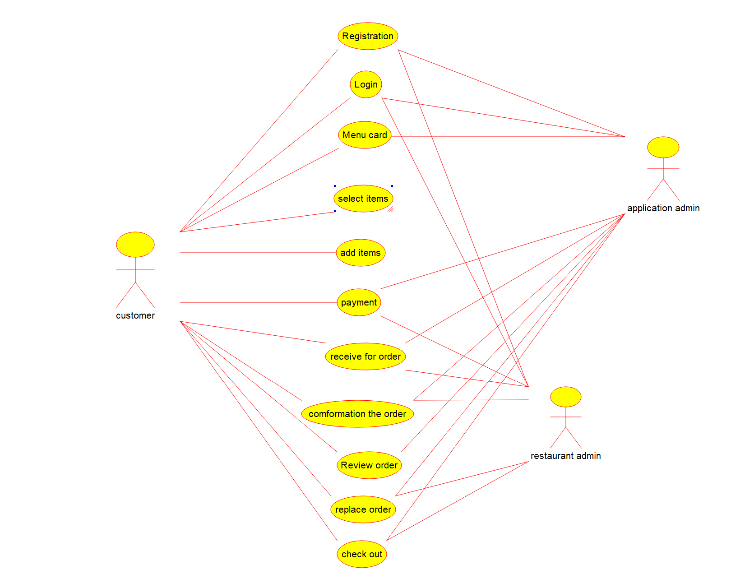

**2. SEQUENCE DIAGRAM:**

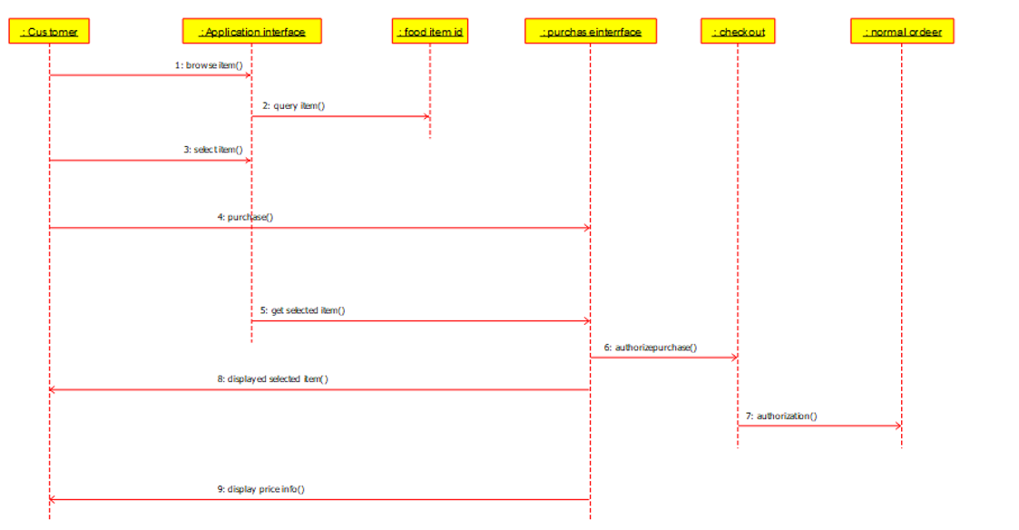

**3. CLASS DIAGRAM**

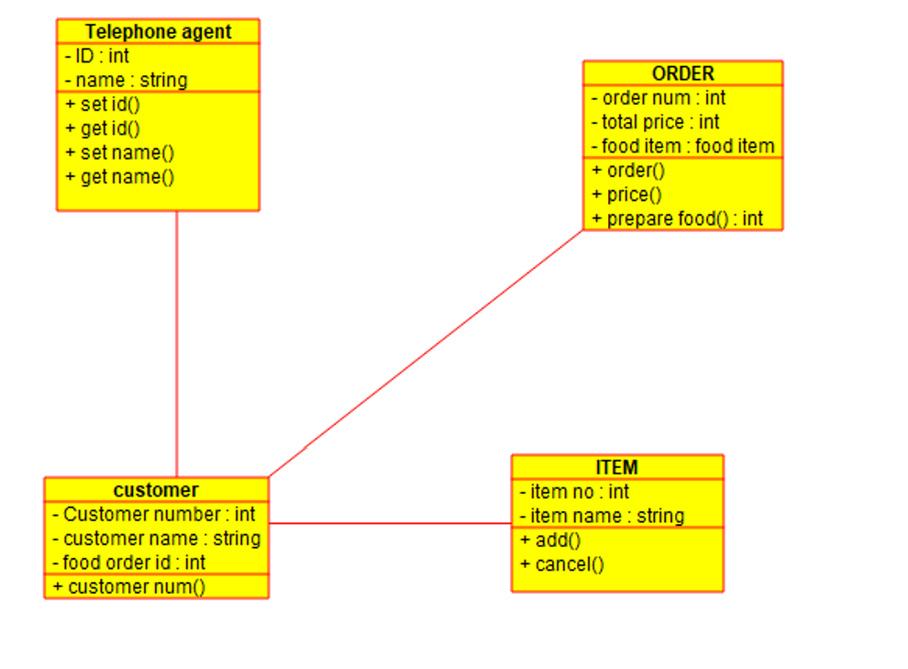

**4. ACTIVITY DIAGRAM:**

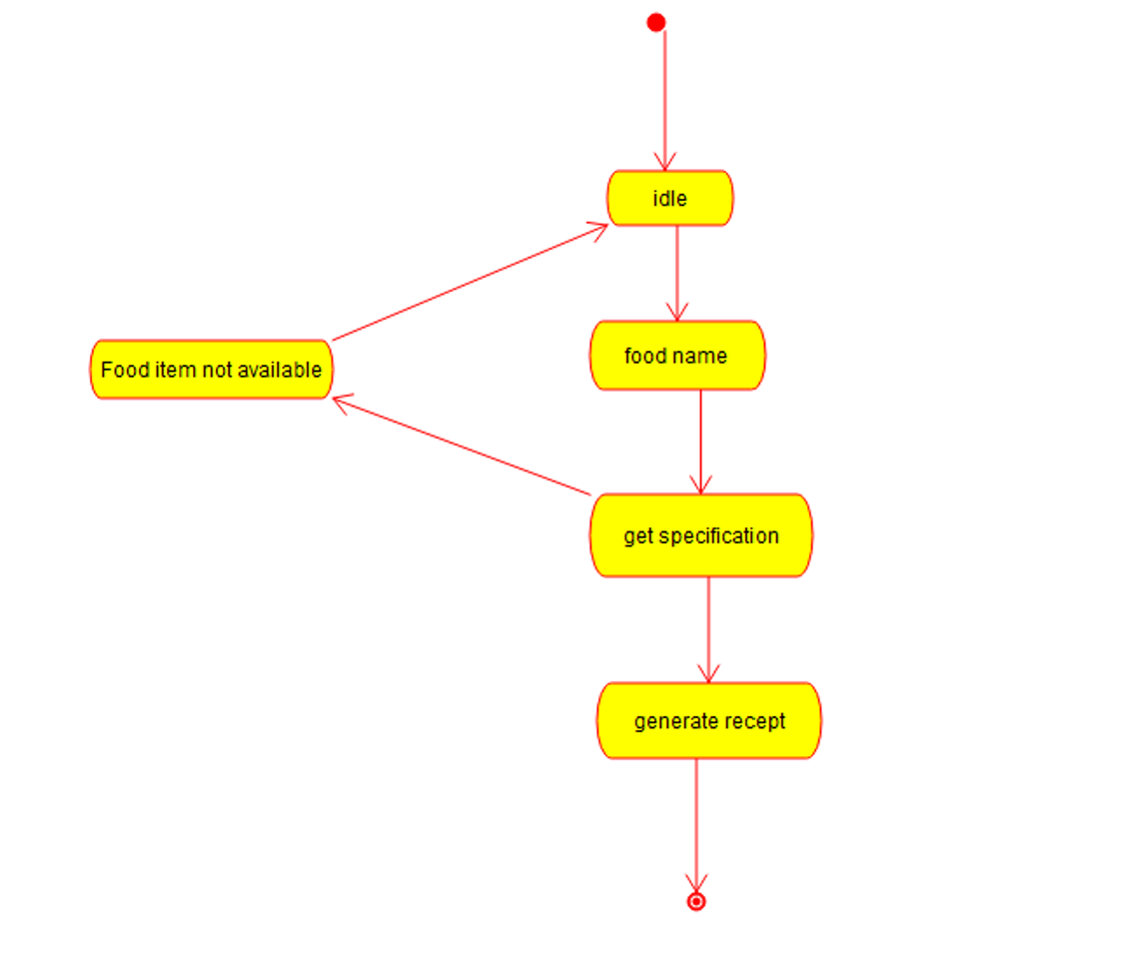

**a5.Online Shopping system**

**1.USE CASE DIAGRAM:**

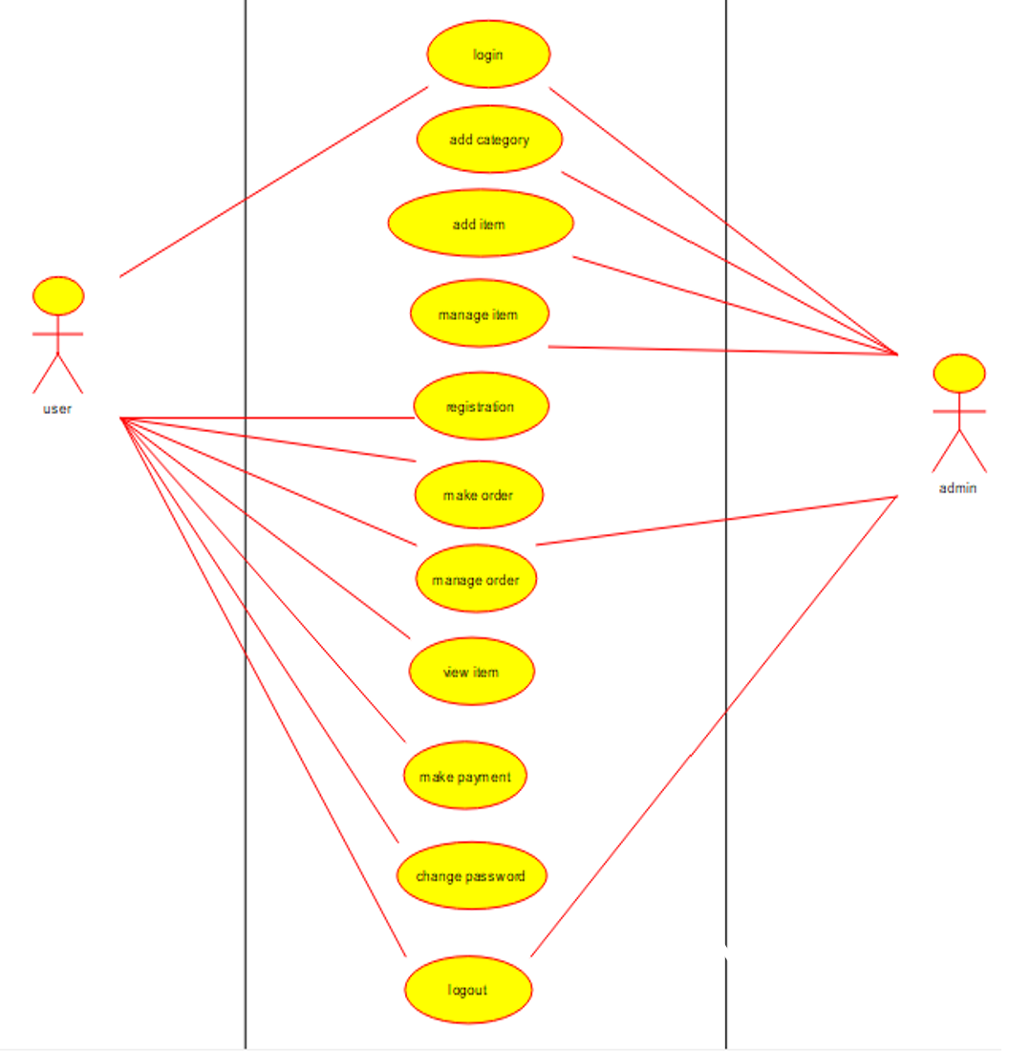

**2. SEQUENCE DIAGRAM:** 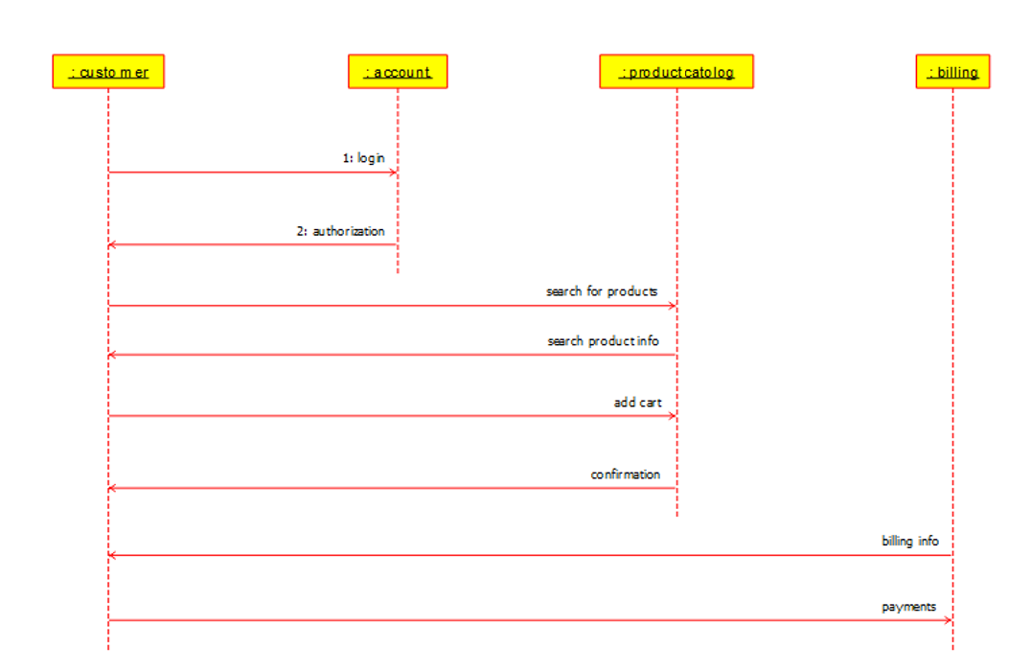

**3. CLASS DIAGRAM:**

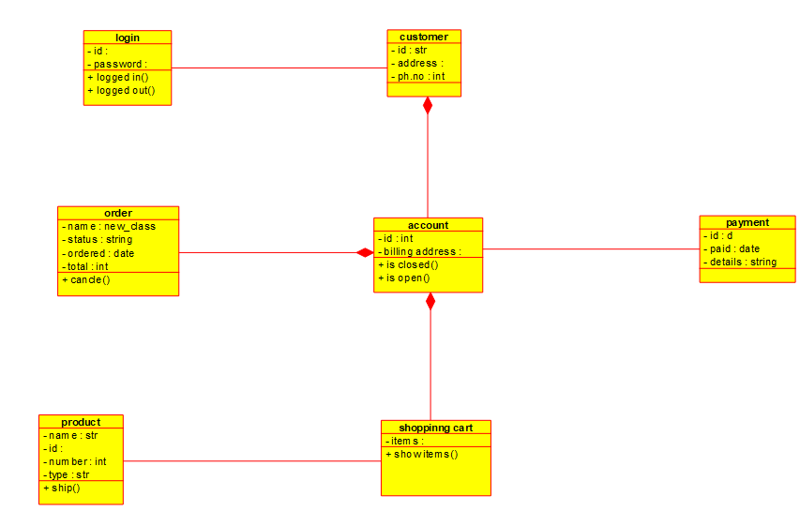

**4. ACTIVITY DIAGRAM:**

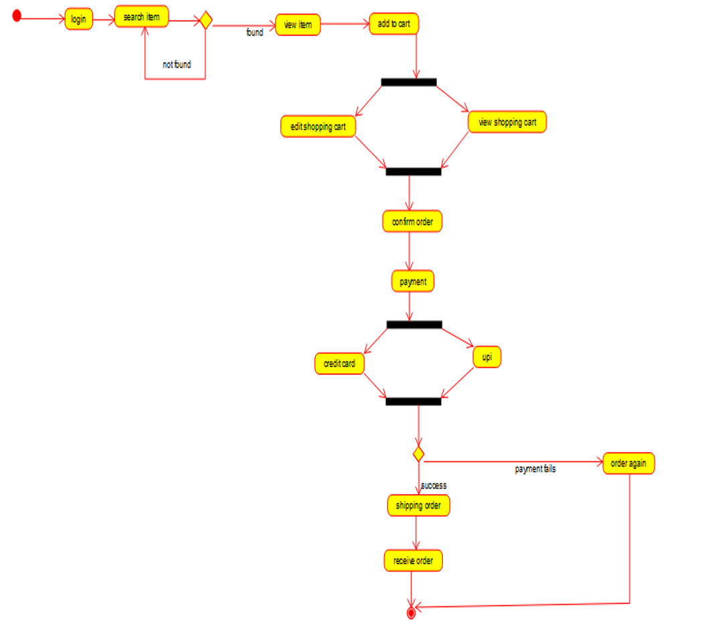

**a6.Online Voting System**

**1.USE CASE DIAGRAM:**

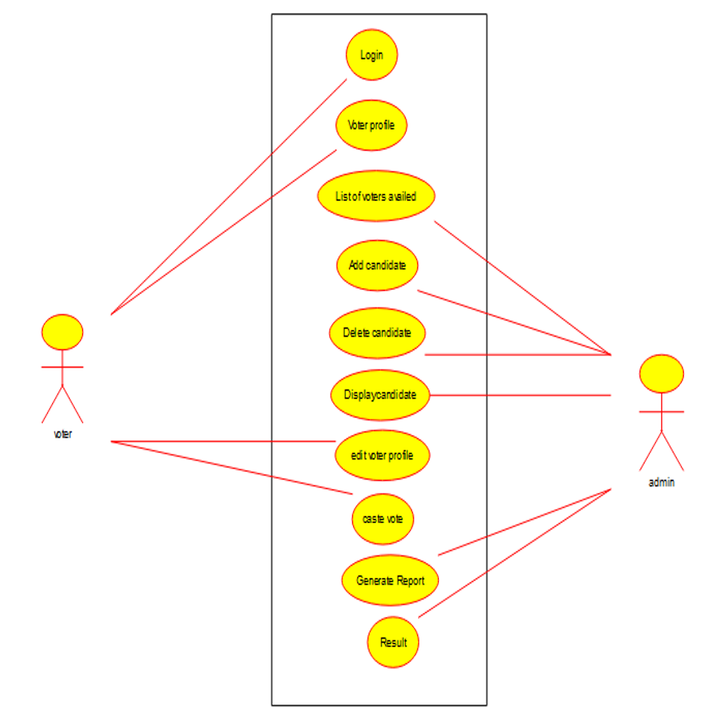

**2. SEQUENCE DIAGRAM:**

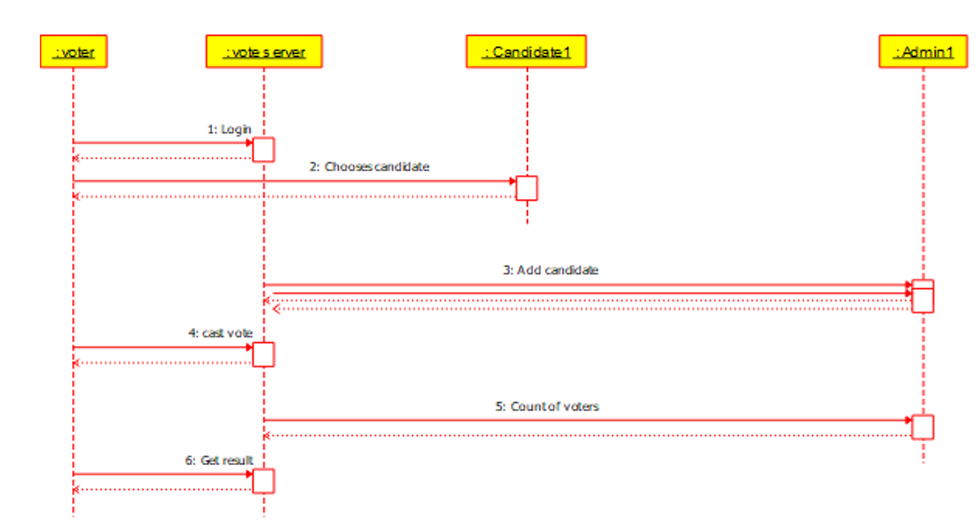

**3. CLASS DIAGRAM:**

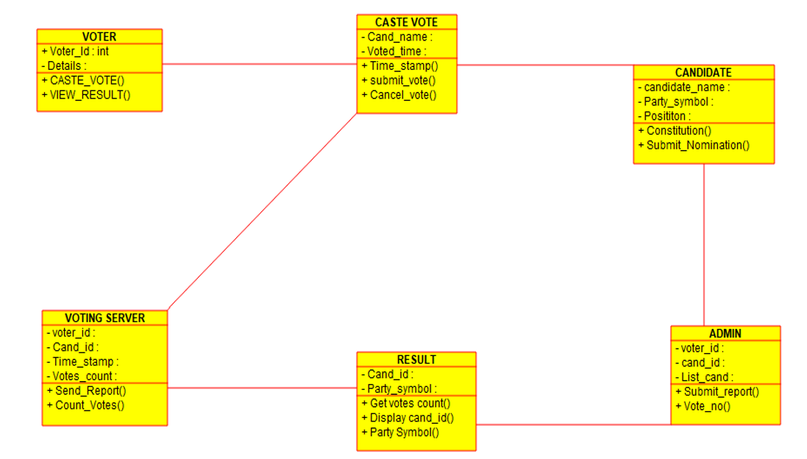

**4. ACTIVITY DIAGRAM:**

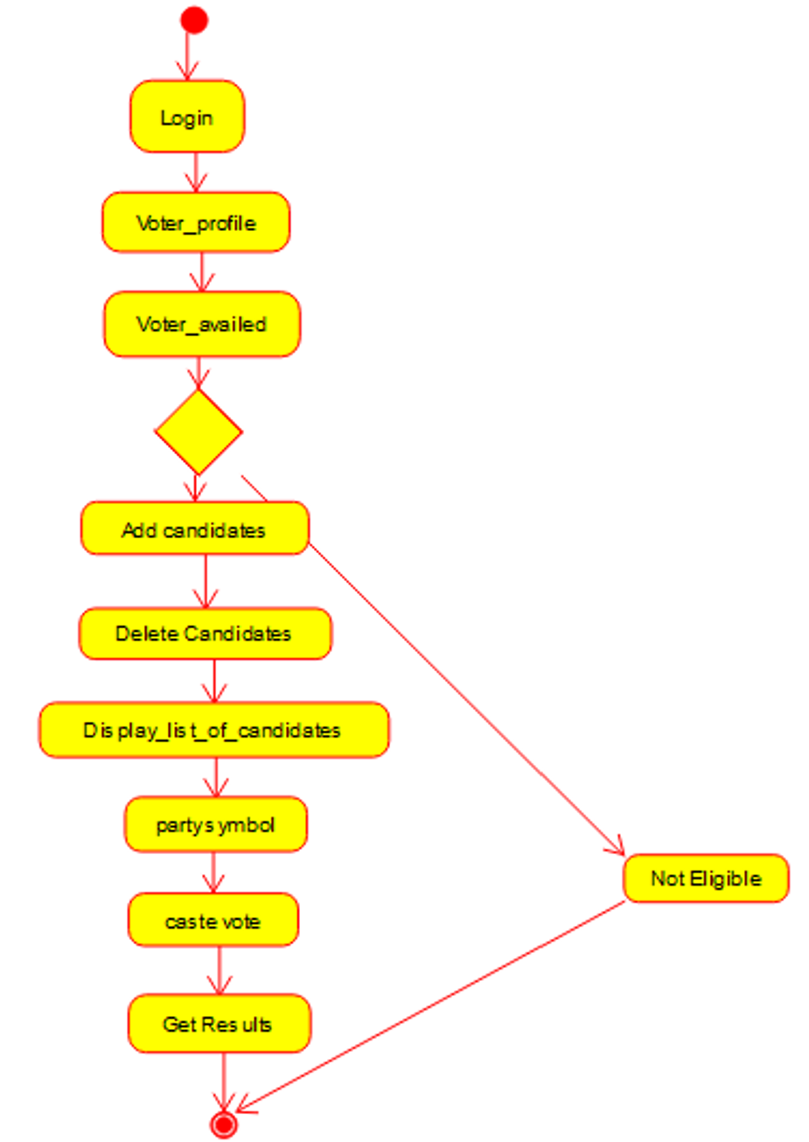

**a7.Hospital management System**

**1.USE CASE DIAGRAM:**

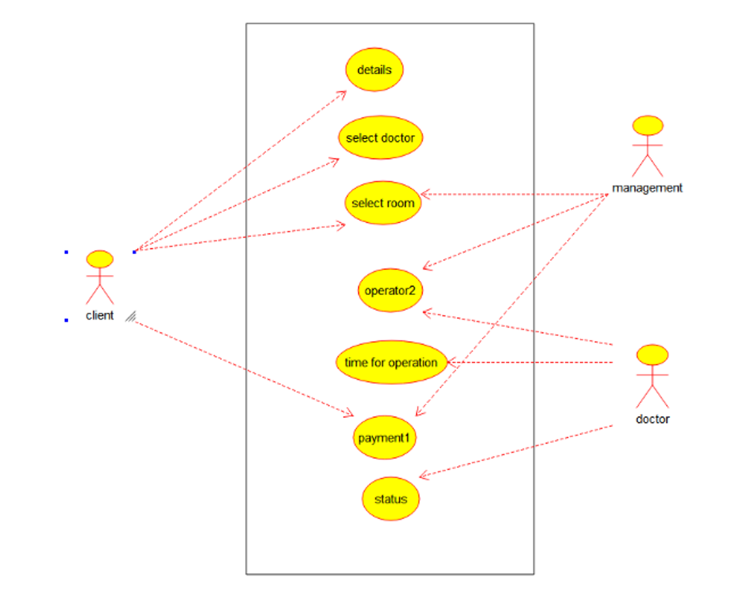

**2. SEQUENCE DIAGRAM:** 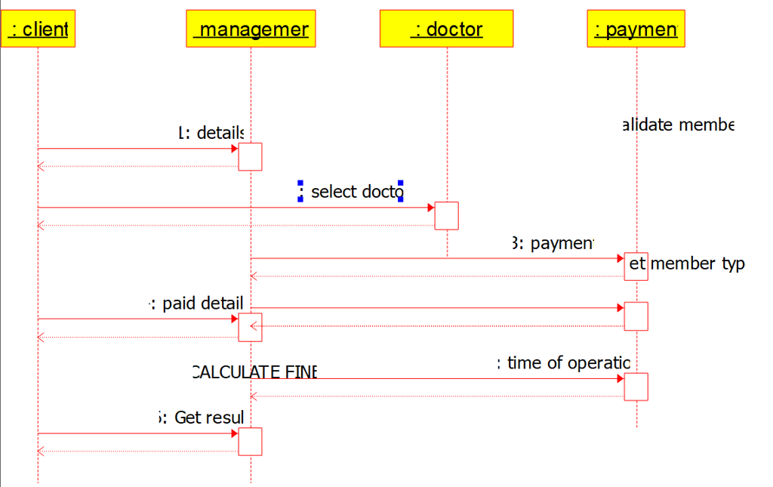

**3. CLASS DIAGRAM:**

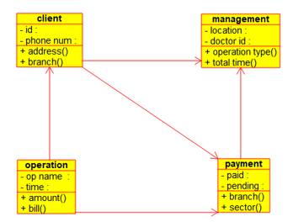

**4. ACTIVITY DIAGRAM:**

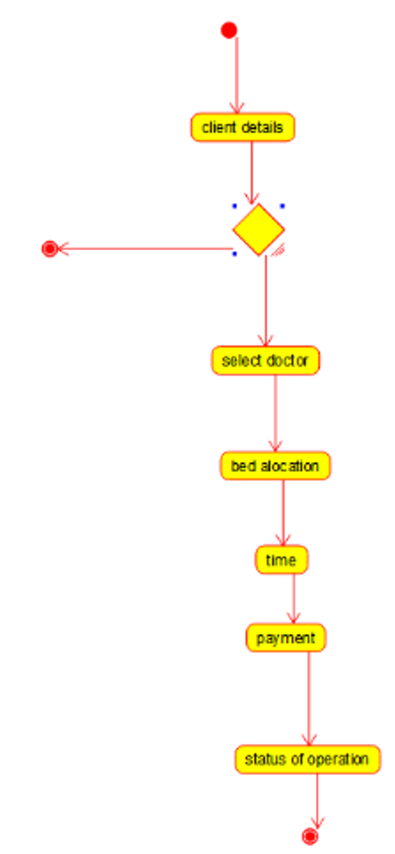

**a8.Online Banking System**

**1.USE CASE DIAGRAM:**

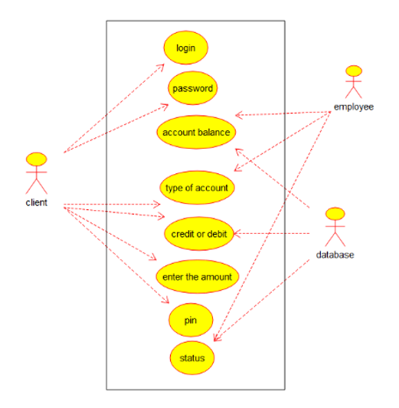

**2. SEQUENCE DIAGRAM:**

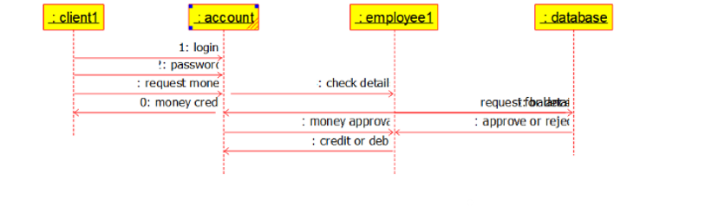

**3. CLASS DIAGRAM:**

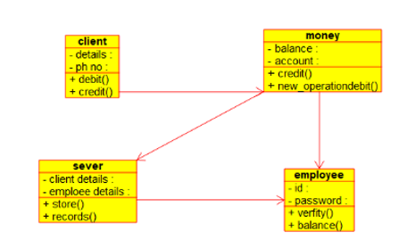

**4. ACTIVITY DIAGRAM:**

